

Project Report
(PETV140)
Topic: Smart Parking Management System

Submitted to:
Faculty: Mahipal Singh Papola, Deepak Kumar
(Department of Computer Science and Engineering Lovely Professional University)

Submitted By:
1.Kushubh Gautam (1247895)
2. Abhinav Singh (12406431)
3. Shubham Shankar (12405922)
4. Arpit (12401163)
5. Ashish (12404573)
Project Links:
GitHub Repository: https://github.com/abhi-6431/smart-parking-management-system
Deployment Link: https://smart-parking-management-system-1-xoew.onrender.com

2. Abstract
The Smart Parking Management System is a full-stack web application designed to simplify parking space management by providing users with an efficient platform to locate, reserve, and manage parking slots. The system allows users to check real-time parking availability, reserve parking spaces, and manage vehicle entry and exit digitally. It eliminates the inconvenience of manual parking management by offering a secure and user-friendly online solution that is accessible from any device.
Objectives
- Develop an online platform for efficient parking slot management.
- Provide secure user authentication and parking reservation.
- Offer a responsive and user-friendly interface.
- Ensure efficient storage and retrieval of parking information.

Technologies Used
Technology | Purpose
React.js | Frontend Development
HTML5 | Web Structure
CSS3 | User Interface Styling
JavaScript | Client-side Functionality
Express.js (Node.js) | Backend Development
MySQL / SQLite | Database Management
Git | Version Control
VS Code | Development Environment
Postman | API Testing

Key Features
- User Registration and Secure Login
- View Available Parking Slots
- Online Parking Slot Reservation
- Vehicle Entry and Exit Management
- Parking History Management
- Admin Dashboard
- Real-Time Parking Availability
- Responsive Design
- Secure Database Management

Outcome
The project successfully demonstrates the implementation of a modern web-based Smart Parking Management System using full-stack development technologies. It provides a scalable, secure, and responsive solution while applying Data Structures and Algorithms such as Queue, HashMap, Priority Queue, Searching, and Sorting to optimize parking allocation and improve parking management efficiency.

3. Introduction
3.1 Project Overview
The Smart Parking Management System is a web-based application developed to simplify and automate parking management. The application enables users to create an account, log in securely, check available parking spaces, reserve parking slots, and manage vehicle entry and exit through an intuitive interface. By integrating modern frontend and backend technologies, the system provides a smooth parking experience while ensuring secure storage and management of user and parking data.
The project is developed using React.js for the frontend, Express.js (Node.js) for backend services, and MySQL/SQLite for database management. The application is built with a modular architecture, where each functionality such as authentication, parking slot management, reservation, and administration is implemented independently. This approach improves scalability, maintainability, and overall system performance.

3.2 Problem Statement
Traditional parking management systems often rely on manual processes or basic digital solutions, leading to several challenges for both vehicle owners and parking administrators.
Problems in Traditional Parking System
• Long waiting time while searching for available parking spaces.
• Difficulty in checking parking slot availability in real time.
• Manual maintenance of parking records.
• Higher chances of parking allocation errors.
• Limited accessibility and inconvenience for users.
• Increased workload for parking management staff.
These challenges create the need for a modern Smart Parking Management System that enables users to reserve parking spaces quickly and manage parking operations efficiently.

3.3 Objectives
The primary objectives of the Smart Parking Management System are:
• To develop a secure and user-friendly online parking management platform.
• To provide authenticated access for registered users.
• To allow users to view available parking slots in real time.
• To enable easy parking slot reservation and vehicle management.
• To maintain parking records securely in the database.
• To create a responsive application that works across different devices.
• To implement a scalable architecture using modern web development technologies and Data Structures & Algorithms.

3.4 Existing System
In many traditional parking facilities, parking management is performed manually or through basic systems with limited functionality. These methods often fail to provide an efficient parking experience.
Limitations of the Existing System
• Manual allocation of parking spaces.
• Long waiting time during peak hours.
• Lack of real-time parking slot availability.
• Poor user experience due to outdated systems.
• Limited accessibility from mobile devices.
• Difficult record management and maintenance.

3.5 Proposed System
The proposed Smart Parking Management System addresses the limitations of traditional parking methods by providing a secure, responsive, and automated web application.
Features of the Proposed System
• Secure user registration and login.
• Real-time parking slot availability.
• Online parking slot reservation.
• Vehicle entry and exit management.
• Store parking records securely in MySQL/SQLite.
• Responsive design for desktop and mobile devices.
• REST API developed using Express.js.
• Fast deployment and easy accessibility.
The modular architecture allows future enhancements such as online payment integration, QR Code-based vehicle entry, GPS-based parking navigation, smart notifications, and AI-based parking prediction.

3.6 Scope of the Project
The Smart Parking Management System is designed to provide a secure, efficient, and automated platform for managing parking spaces. The project focuses on improving parking management while demonstrating the implementation of modern full-stack web development technologies.
Current Scope
• Online user registration and login.
• View available parking slots.
• Reserve parking slots online.
• Vehicle entry and exit management.
• Store parking records securely in the database.
• View parking history.
• Responsive interface for desktop and mobile devices.
Future Scope
• Online payment gateway integration.
• QR Code-based parking access.
• GPS navigation to available parking spaces.
• Email and SMS notifications.
• AI-based parking prediction.
• Admin analytics dashboard.
• Multi-location parking management.
• IoT sensor integration for real-time updates.

3.7 Technology Stack
The project utilizes modern web development technologies to build a scalable and responsive Smart Parking Management System.
Technology | Purpose
React.js | Frontend development using reusable components
HTML5 | Structure of Web Pages
CSS3 | Responsive UI Styling
JavaScript (ES6) | Application Logic
Express.js (Node.js) | Backend Development
MySQL / SQLite | Database Management
Git | Version Control
VS Code | Development Environment
Postman | API Testing
Advantages of the Selected Technologies
• Fast application performance.
• Component-based architecture.
• Responsive user interface.
• Secure database management.
• Easy scalability and maintenance.
• Simple deployment process.

3.8 Software Requirements
Development Software
Software | Purpose
Visual Studio Code | Code Editor
Node.js | JavaScript Runtime
npm | Package Manager
Git | Version Control
MySQL / SQLite | Database
Postman | API Testing
Google Chrome | Testing Browser
Programming Languages
• JavaScript
• HTML5
• CSS3
• SQL

3.9 Hardware Requirements
Minimum Requirements
Component | Specification
Processor | Intel Core i3 / Ryzen 3
RAM | 4 GB
Storage | 20 GB Free Space
Internet | Broadband Connection
Browser | Chrome / Edge / Firefox
Recommended Requirements
Component | Specification
Processor | Intel Core i5 / Ryzen 5 or Above
RAM | 8 GB or Above
Storage | SSD (50 GB Free Space)
Internet | High-Speed Broadband
Browser | Latest Chrome or Edge

3.10 System Architecture
The Smart Parking Management System follows a Client–Server Architecture, where the React.js frontend communicates with the Express.js backend through REST APIs, and parking information is stored in the MySQL/SQLite database.
Architecture Workflow
User
│
▼
React.js Frontend
│
▼

Express.js Backend API
│
▼
MySQL / SQLite Database
│
▼
Parking Slot Information
Working Flow
- User opens the application.
- User registers or logs in.
- Available parking slots are fetched from the database.
- User selects a parking slot.
- User reserves the selected parking space.
- Parking details are stored in the database.
- User can view parking history and reservation status.

3.11 Database Design
The application uses MySQL / SQLite to store and manage parking information.
Main Database Tables
Table Name | Purpose
Users | Stores user information
ParkingSlots | Stores parking slot details
Reservations | Stores parking reservation records
Users Table
Stores:
• User ID
• Name
• Email
• Password
• Mobile Number
ParkingSlots Table
Stores:
• Slot ID
• Slot Number
• Slot Status
• Vehicle Type
• Availability Status
Reservations Table
Stores:
• Reservation ID
• User ID
• Slot ID
• Vehicle Number
• Reservation Date
• Entry Time
• Exit Time
• Reservation Status
Database Features
• Primary Keys
• Foreign Key Relationships
• Secure User Authentication
• Indexed Queries for Better Performance
• Efficient Data Retrieval

3.12 Project Modules
The Smart Parking Management System is divided into multiple functional modules to improve maintainability and scalability.
1. Authentication Module
Functions:
• User Registration
• User Login
• Secure Authentication
• Session Management

2. Parking Management Module
Functions:
• Display Available Parking Slots
• View Parking Slot Details
• Update Slot Availability

3. Reservation Module
Functions:
• Parking Slot Selection
• Reserve Parking Slot
• Store Reservation Details
• Prevent Duplicate Reservations

4. User Dashboard Module
Functions:
• View Parking History
• Manage User Profile
• View Reservation Status

5. Database Module
Functions:
• Store User Information
• Store Parking Slot Information
• Store Reservation Records
• Perform CRUD Operations

4. Algorithm
The Smart Parking Management System follows a modular approach where each major functionality is implemented using a separate algorithm. The following algorithms describe the workflow of the application's core modules.

4.1 User Registration Algorithm
Objective
To create a new user account in the Smart Parking Management System.
Flowchart
┌───────┐ → ┌──────────────────┐ ┌──────────────────┐
│ Start │ │ Enter User Details│ │ Validate Inputs│
└───────┘ └──────────────────┘ └─────────┬────────┘
│
Email Exists? ────┼──────► No
│ Yes │
▼ ▼
┌──────────────┐ ┌────────────────┐
│ Show Error │ │ Create Account │
└──────────────┘ └────────┬───────┘
│
▼
┌────────────────┐
│ Redirect Login │
└───────┬────────┘
│
▼
┌──────┐
│ End │
└──────┘
Algorithm Steps
- User enters Name, Email, Password and Vehicle Details.
- Validate all input fields.
- Check whether the email is already registered.
- If the email exists, display an error message.
- Otherwise, create a new account.
- Store user information securely.
- Display a success message.
- Redirect the user to the Login page.
Time Complexity: O(1) Space Complexity: O(1)
DSA Concepts Used
• String Validation
• Authentication
• Database Lookup

4.2 User Login Algorithm
Objective
To authenticate users and provide secure access.
Algorithm Steps
- User enters Email and Password.
- Validate credentials.
- Send authentication request.
- If authentication fails, display an error.
- If successful, create a session.
- Redirect to Dashboard.
Flowchart
┌───────┐ → ┌──────────────────┐ → ┌─────────────────┐
│ Start │ │ Enter Credentials│ │ Validate Login │
└───────┘ └──────────────────┘ └────────┬────────┘
│
Valid User? ────┼──────► Yes
│ No │
▼ ▼
┌─────────────┐ ┌────────────────┐
│ Show Error │ │ Create Session │
└─────────────┘ └────────┬───────┘
│
▼
┌────────────────┐
│ Redirect Home │
└───────┬────────┘
│
▼
┌──────┐
│ End │
└──────┘
Time Complexity: O(1) Space Complexity: O(1)
DSA Concepts Used
• String Matching
• Authentication
• Session Management

4.3 Parking Slot Retrieval Algorithm
Objective
To retrieve available parking slots from the database.
Algorithm Steps
- Open Dashboard.
- Request parking slot data.
- Retrieve slot information.
- Store available slot records.
- Display available parking slots.
Flowchart
┌───────┐ → ┌──────────────────┐ → ┌──────────────────┐
│ Start │ │ Request Slots │ │ Fetch from DB │
└───────┘ └──────────────────┘ └────────┬─────────┘
│
▼
┌──────────────────┐
│ Store Slot Data │
└────────┬─────────┘
│
▼
┌──────────────────┐
│ Display Slots │
└────────┬─────────┘
│
▼
┌──────┐
│ End │
└──────┘
Time Complexity: O(n) Space Complexity: O(n)
DSA Concepts Used
• Array Traversal
• Database Query
• Data Rendering

4.4 Parking Slot Selection Algorithm
Objective
To allow users to reserve only available parking slots.
Algorithm Steps
- Display parking slot layout.
- User selects a parking slot.
- Verify slot availability.
- If occupied, display an error.
- Otherwise, reserve the selected slot.
- Continue to reservation confirmation.
Flowchart
┌───────┐ → ┌──────────────────┐ → ┌──────────────────┐
│ Start │ │ Display Slots │ │ Select Slot │
└───────┘ └──────────────────┘ └────────┬─────────┘
│
Slot Available? ───┼──────► Yes
│ No │
▼ ▼
┌──────────────┐ ┌─────────────────┐
│ Show Error │ │ Reserve Slot │
│ Slot Occupied│ │ Successfully │
└──────────────┘ └────────┬────────┘
│
▼
┌────────────────┐
│ Continue │
│ Reservation │
└───────┬────────┘
│
▼
┌──────┐
│ End │
└──────┘
Time Complexity: O(n) Space Complexity: O(n)
DSA Concepts Used
• Arrays
• Queue
• Linear Search
• Boolean State Tracking

4.5 Parking Reservation Algorithm
Objective
To confirm the parking reservation and store reservation details in the database.
Algorithm Steps
- Verify user authentication.
- Retrieve selected parking slot.
- Retrieve vehicle details.
- Generate reservation information.
- Save reservation in the database.
- Display reservation confirmation.
Flowchart
┌───────┐ → ┌──────────────────┐ → ┌──────────────────┐
│ Start │ │ Verify User │ │ Retrieve Parking │
└───────┘ └──────────────────┘ │ Information │
└────────┬─────────┘
│
▼
┌──────────────────┐
│ Save to Database │
└────────┬─────────┘
│
▼
┌──────────────────┐
│ Reservation │
│ Successful │
└────────┬─────────┘
│
▼
┌──────┐
│ End │
└──────┘
Time Complexity: O(1) Space Complexity: O(1)
DSA Concepts Used
• CRUD Operations
• Database Insertion
• Record Management

4.6 Parking History Retrieval Algorithm
Objective
To display all previous parking reservations of the logged-in user.
Algorithm Steps
- Verify user authentication.
- Fetch parking records.
- Filter records for the current user.
- Display parking history.
Flowchart
┌───────┐ → ┌──────────────────┐ → ┌──────────────────┐
│ Start │ │ Verify User │ │ Fetch Records │
└───────┘ └──────────────────┘ └────────┬─────────┘
│
▼
┌──────────────────┐
│ Filter User Data │
└────────┬─────────┘
│
▼
┌──────────────────┐
│ Display History │
└────────┬─────────┘
│
▼
┌──────┐
│ End │
└──────┘
Time Complexity: O(n) Space Complexity: O(n)
DSA Concepts Used
• Arrays
• Filtering
• Traversal
• Database Query

Algorithm Summary
Algorithm | Time Complexity | Space Complexity
User Registration | O(1) | O(1)
User Login | O(1) | O(1)
Parking Slot Retrieval | O(n) | O(n)
Parking Slot Selection | O(n) | O(n)
Parking Reservation | O(1) | O(1)
Parking History Retrieval | O(n) | O(n)

5. Results
The Smart Parking Management System was successfully developed and tested using modern web technologies. The application performed as expected, providing users with a secure, efficient, and responsive parking management experience. All major functionalities, including user authentication, parking slot management, slot reservation, vehicle entry/exit management, and parking history, were successfully tested and verified.

5.1 Home Page
Description
The Home Page serves as the entry point of the application. It displays the parking dashboard with available parking slots, system overview, and navigation options in a clean and responsive layout.
Features
• Responsive Navigation Bar
• Dashboard Overview
• Available Parking Slot Display
• Clean and Modern User Interface
• Mobile-Friendly Design
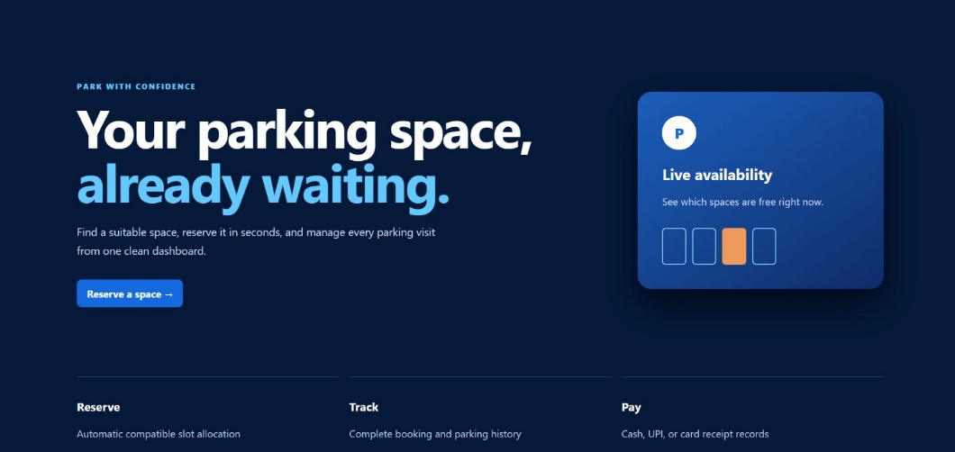

5.2 User Authentication
Description
The authentication module allows users to create a new account and securely log in to the Smart Parking Management System.
Features
• User Registration
• Secure Login
• Input Validation
• Session Management
• Error Handling
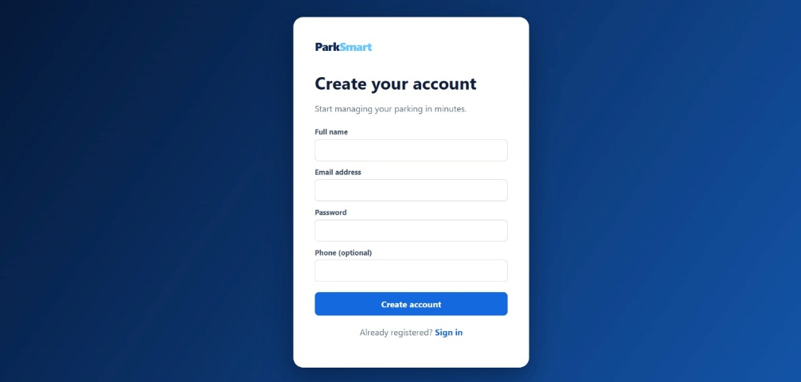

5.3 Parking Slot Listing
Description
The Parking Slot Listing page retrieves parking slot information from the MySQL/SQLite database and displays available and occupied parking spaces dynamically.
Features
• Dynamic Parking Slot Display
• Real-Time Slot Availability
• Slot Number and Status
• Responsive Card Layout
• Live Data Rendering
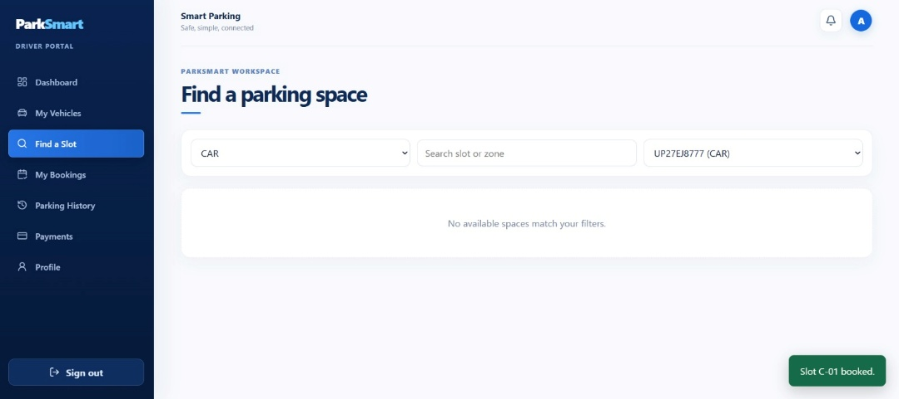

5.4 Parking Slot Reservation
Description
The Parking Slot Reservation module enables users to select and reserve available parking spaces. Occupied and available slots are displayed separately to avoid duplicate reservations.
Features
• Interactive Parking Layout
• Available and Occupied Slot Indication
• Slot Reservation Validation
• User-Friendly Interface
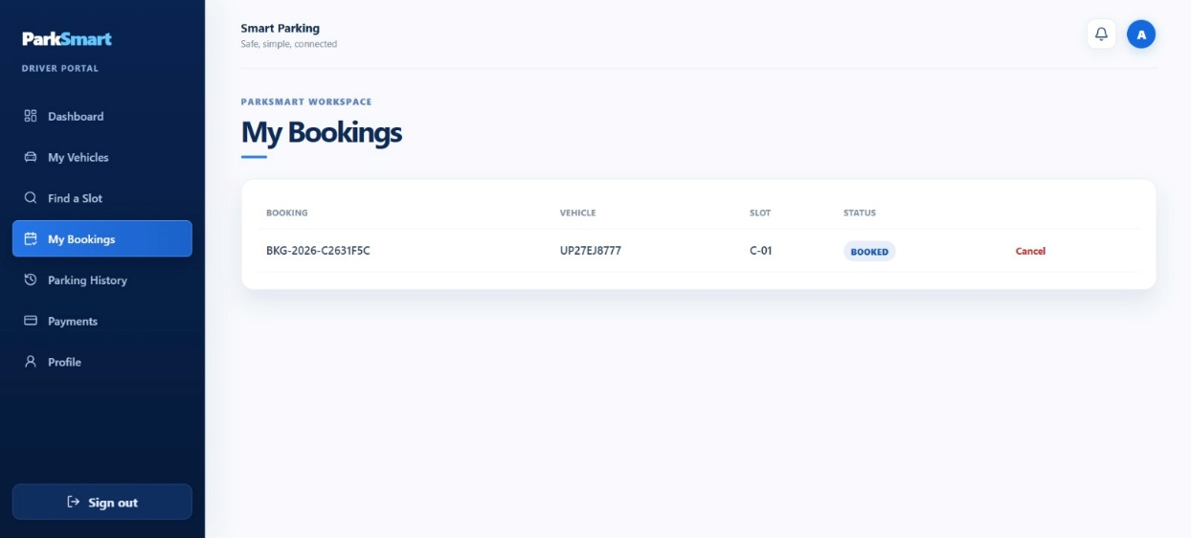

5.5 Parking Reservation Confirmation
Description
After selecting an available parking slot, users can confirm their reservation. The reservation details are securely stored in the MySQL/SQLite database.
Features
• Reservation Confirmation
• Secure Database Storage
• Automatic Reservation Record Generation
• User-Specific Reservations

5.6 Parking History
Description
Users can view all their previous parking reservations through the Parking History page. Only authenticated users can access their personal parking records.
Features
• Parking History Display
• User-Specific Records
• Secure Data Retrieval
• Responsive Layout

5.7 Database Integration
Description
The system uses Express.js with MySQL/SQLite to provide secure backend services and database management for the application.
Database Features
• MySQL/SQLite Database
• Secure User Authentication
• CRUD Operations
• Fast Data Retrieval
• Data Integrity and Validation
• Efficient Parking Record Management

5.8 Testing Results
The application was tested for all major functionalities to ensure smooth operation, reliability, and data consistency.
Module | Test Case | Result
User Registration | New user registration | Passed
User Login | Valid login credentials | Passed
Parking Slot Listing | Retrieve parking slot data | Passed
Parking Slot Reservation | Reserve available parking slot | Passed
Parking Reservation | Store reservation details | Passed
Parking History | Retrieve user parking records | Passed
Database Connection | MySQL/SQLite connection | Passed
Responsive Design | Desktop & Mobile View | Passed

6. Conclusion
The Smart Parking Management System was successfully developed as a modern full-stack web application that simplifies parking space management and reservation. The project combines a responsive frontend with a secure backend to provide users with a smooth, efficient, and reliable parking experience.
The application enables users to register, log in securely, view available parking slots, reserve parking spaces, manage vehicle entry and exit, and access their parking history. By integrating React.js, Express.js, Node.js, and MySQL/SQLite, the system ensures reliable performance, secure data management, and an intuitive user interface.
The project also demonstrates the practical implementation of software engineering principles such as modular architecture, client-server communication, database integration, and user authentication. Additionally, it incorporates Data Structures and Algorithms (DSA) concepts including Queue, HashMap, Priority Queue, Searching, Sorting, and efficient database operations to optimize parking allocation and management.

Objectives Achieved
• Developed a responsive Smart Parking Management System.
• Implemented secure user authentication.
• Created dynamic parking slot listing and availability tracking.
• Successfully integrated parking slot reservation.
• Stored parking records securely in MySQL/SQLite.
• Displayed user-specific parking history.
• Successfully developed a scalable full-stack web application.

Advantages of the System
• Simple and user-friendly interface.
• Secure authentication and authorization.
• Fast and responsive performance.
• Efficient parking slot allocation.
• Modular and scalable architecture.
• Accessible from desktop and mobile devices.
• Easy maintenance and future enhancement.

Future Enhancements
The application can be further improved by adding the following features:
• Online payment gateway integration.
• QR Code-based vehicle entry and exit.
• Email and SMS parking notifications.
• Automatic parking fee calculation.
• GPS-based parking slot navigation.
• Admin analytics dashboard.
• Multi-location parking management.
• IoT sensor integration for real-time slot monitoring.
• AI-based parking prediction and recommendations.
• Smart traffic and congestion analysis.

7. References
The following resources were referred to during the design and development of the project:
• React Documentation – https://react.dev/
• Node.js Documentation – https://nodejs.org/docs/
• Express.js Documentation – https://expressjs.com/
• MySQL Documentation – https://dev.mysql.com/doc/
• SQLite Documentation – https://sqlite.org/docs.html
• JavaScript Documentation (MDN Web Docs) – https://developer.mozilla.org/
• HTML5 Specification (W3C) – https://www.w3.org/TR/html5/
• CSS Documentation (MDN Web Docs) – https://developer.mozilla.org/en-US/docs/Web/CSS
• Git Documentation – https://git-scm.com/doc
• Postman Documentation – https://learning.postman.com/docs/

